PF Lab #7 Assignment

Mohammad Yehya Hayati, 21K-3309

Table of Contents

**Question#1:** 2

**Question#2:** 3

**Question#3:** 4

**Question#4:** 5

**Question#5:** 6

**Question#6:** 8

**Question#7:** 11

**Question#8:** 12

**Question#9:** 12

**Question#10:** 13

# **Question#1:**

#include <stdio.h>

int main()

{

//Q1

int num,count=0;

printf("Please enter any number: ");

scanf("%d",&num);

printf("The Factors are: ");

for (int i = 1 ; i <= num ; i++)

{

if (num%i == 0 )

{

printf("%d ",i);

count++;

}

}

if (count == 2)

{

printf("\nIt is a prime number!");

}

}

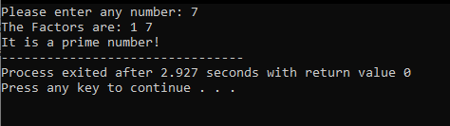

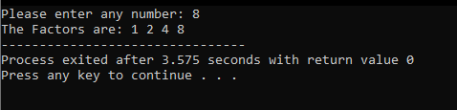

# **Question#2:**

#include <stdio.h>

#include <math.h>

int main()

{

printf("The special number(s) is/are : ");

for (int i = 100; i<=170; i++)

{

if (i == pow(i/100,3)+pow(i%100/10,3)+pow(i%10,3))

{

printf("%d ",i);

}

}

}

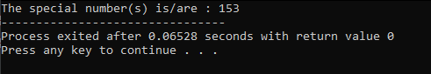

# **Question#3:**

#include <stdio.h>

int main()

{

int num;

printf("Enter the number to find the multipacation table: ");

scanf("%d",&num);

for (int i=1 ; i<=10 ; i++)

{

printf("%d * %d = %d\n",num,i,num*i);

}

}

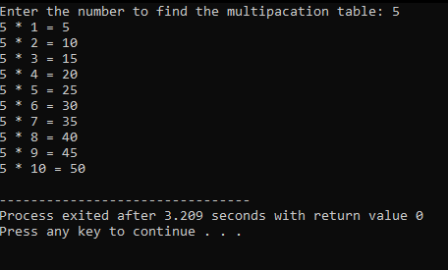

# **Question#4:**

#include <stdio.h>

#include <math.h>

int main()

{

float interest, principle, rate, years, times_year;

for (int i=1 ; i<=10 ; i++)

{

printf("Entry number %d\n",i);

printf("Please enter the principle amount: ");

scanf("%f",&principle);

printf("Please enter the rate of the interest: ");

scanf("%f",&rate);

printf("Please enter the number of years: ");

scanf("%f",&years);

printf("Please enter the times per year: ");

scanf("%f",&times_year);

interest = principle * pow((1+0.01*rate/times_year),years*times_year);

printf("The interest after compounding is: %f\n\n",interest);

}

}

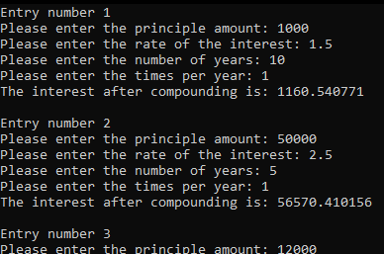

# **Question#5:**

#include <stdio.h>

int main()

{

int marks=0,out=0,ex=0,good=0,avg=0,Bavg=0,adq=0,pass=0,fail=0;

for (int i = 1 ; i<=10 ; i++)

{

printf("Please enter student marks: ");

scanf("%d",&marks);

switch (marks)

{

case 90 ... 100:

out++;

break;

case 86 ... 89:

ex++;

break;

case 75 ... 85:

good++;

break;

case 70 ... 74:

avg++;

break;

case 66 ... 69:

Bavg++;

break;

case 62 ... 65:

adq++;

break;

case 50 ... 61:

pass++;

break;

case 0 ... 49:

fail++;

break;

default:

printf("Invalid Input\n");

break;

}

}

printf("The number of students that passed are %d\n",pass + out + ex + good + avg + Bavg + adq);

printf("The number of students that failed are %d\n", fail);

printf("The number of excellent students are %d\n", ex);

printf("The number of above average students are %d\n",good + ex + out);

}

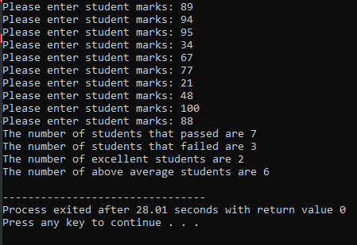

# **Question#6:**

#include <stdio.h>

int main()

{

int marks;

char ans;

while(true)

{

printf("Q1. What is 1+1=?\nA)1\nB)2\nC)3\nD)4\n");

scanf(" %c",&ans);

if (ans == 'B')

{

marks = marks + 4;

}

else marks--;

printf("Q2. What is the value of pi?\nA)3.14\nB)2.71\nC)8.99\nD)8.01\n");

scanf(" %c",&ans);

if (ans == 'A')

{

marks = marks + 4;

}

else marks--;

printf("Q3. What is the value of e?\nA)3.14\nB)2.71\nC)8.99\nD)8.01\n");

scanf(" %c",&ans);

if (ans == 'B')

{

marks = marks + 4;

}

else marks--;

printf("Q4. What is the value of G?\nA)6.67*10^-11\nB)2.71\nC)8.99\nD)8.01\n");

scanf(" %c",&ans);

if (ans == 'A')

{

marks = marks + 4;

}

else marks--;

if (marks == -4)

{

printf("Sorry,you did not qualify for the admission.");

break;

}

printf("Q5. What is the value of Sin(90)?\nA)3\nB)2\nC)1\nD)0\n");

scanf(" %c",&ans);

if (ans == 'C')

{

marks = marks + 4;

}

else marks--;

if (marks == 20)

{

printf("Congratulations, you have qualified for the admission!");

break;

}

printf("Please await further decision.");

break;

}

}

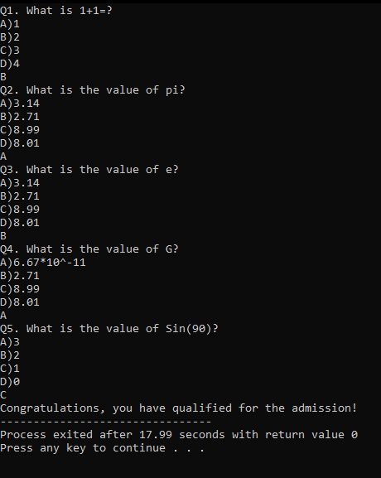

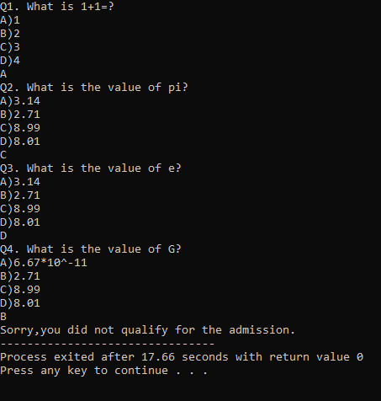

# **Question#7:**

#include <stdio.h>

int main()

{

char grade;

float points;

for ( int i = 1 ; i <= 5 ; i++)

{

printf("Please enter grade for Subject No.%d: ",i);

scanf(" %c",&grade);

switch (grade)

{

case 'A':

points = points + 4;

break;

case 'B':

points = points + 3;

break;

case 'C':

points = points + 2;

break;

case 'D':

points = points + 1;

break;

}

}

printf("The average is %f",points/5);

}

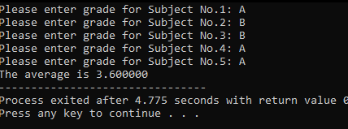

# **Question#8:**

Question number 8 was omitted from submission as it requires knowledge about arrays, pointers, and different libraries like string.h.

# **Question#9:**

#include <stdio.h>

int main()

{

int n;

float marks,max=0,min=99999,sum=0;

printf("Please enter the number of students in the class: ");

scanf("%d",&n);

for (int i = 1 ; i<= n ; i++)

{

printf("Please enter the marks for student No.%d: ",i);

scanf("%f",&marks);

if (marks>max)

{

max = marks;

}

if (marks<min)

{

min = marks;

}

sum = sum + marks;

}

printf("The highest marks in the class is %f\n",max);

printf("The lowest marks in the class is %f\n",min);

printf("The average of the class is %f",sum/n);

}

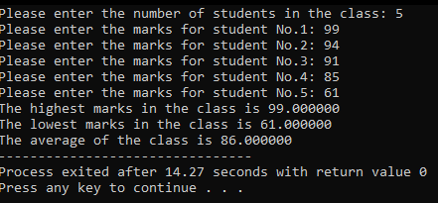

# **Question#10:**

#include <stdio.h>

int main()

{

int accnum, n;

while (true)

{

startbal,price,tot,totcred,credlim,newbal = 0;

float startbal,price,tot,totcred,credlim,newbal;

printf("Enter account number (-1 to end): ");

scanf("%d",&accnum);

if (accnum == -1)

{

break;

}

printf("Enter beginning balance: ");

scanf("%f",&startbal);

printf("How many products you would like to Enter: ");

scanf("%d",&n);

for (int i = 1 ; i <= n ; i++)

{

printf("Enter charges for item %d: ",i);

scanf("%f",&price);

tot = tot + price;

}

printf("\nYour total: %f",tot);

printf("\nEnter total credits: ");

scanf("%f",&totcred);

printf("Enter credit limit: ");

scanf("%f",&credlim);

printf("\nAccount: %d",accnum);

printf("\nCredit limit: %f",credlim);

newbal = startbal - tot + totcred;

printf("\nBalance: %f\n",newbal);

if (newbal < credlim)

{

printf("Credit Limit Not Exceeded.\n\n");

}

else

{

printf("Credit limit exceeded by %f.\n\n",newbal - credlim);

}

printf("-------------------------------------------\n\n");

}

}

